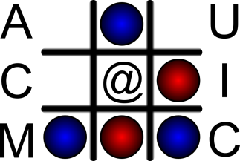 | Association for Computing Machinery  Department of Computer Science (MC 152)  Room 1120 Science and Engineering Offices  851 South Morgan Street  Chicago, IL 60607-7053, USA
Membership Application Form
Membership Renewal
New Member

Basic Information

*First Name __________________________

*Last Name _________________________

Preferred Name ___________________________ (What name do you like to go by?)

*(non-UIC) E-Mail Address ____________________________

Phone Number ____________________________

University Enrollment

*College __________________________ *Major ____________________________

*Expected Graduation Date ________________

*UIC NetID ________________  I am currently NOT a student of UIC

ACM Server/Web Account

*Desired Account Name _____________________________

By signing your name here, you attest to the fact that all information provided on this form is correct to the best of your knowledge

*Signature __________________________________ *Date ______________________

To complete this application, please include the $10 ACM annual student chapter membership fee and bring this form to the ACM office (SELE 2262) and give it to an ACM Officer.

We will notify you via e-mail once your application has been processed!
*Required
ACM Office use only

Sysadmin sign off __________________
Treasurer sign off __________________

 Money Received  Application processed

